CALENDAR

# A Mini Project in C

Academic Year: 2021-22 EVEN SEMESTER

**Semester** : 2

**Course Code** : 18CSS101J

**Course Titl**e : Programming for Problem Solving

***Submitted by***

*ISHIKA JAIN (RA2111003011813)*

***DEPT****: CSE CORE*

*ISHITA BHATNAGAR (RA2111029010060)*

***DEPT****: CSE CN*

*BHAVYA RAJPAL(RA2111030010275)*

***DEPT****:CSE CS*

DEPARTMENT OF COMPUTING

COLLEGE OF ENGINEERING AND TECHNOLOGY

SRM INSTITUTE OF SCIENCE AND TECHNOLOGY, KATTANKULATHUR-603 203

## AIM

To create a Calendar which allows user to view calendar in a neat and convenient manner.

## ABSTRACT

This project is a simple project built in C language.

This project has following features –

1. It displays a nicely formatted calendar of every day of every month.
2. The calendar application presented here is a very simple console application developed using C programming language.
3. It is compiled in Eclipse using eclipse java compiler.

## ALGORITHM

**Step 1:** Start.

**Step 2:** Declare int variable- get_1st_weekDay, year, day.

**Step 3:** Statement: day=Remainder of {[(year-1) × 365] + [(year-1)/4]– [{year-1)/100] + [(year/400)+1]} divided by 7.

**Step 4:** Declare int variables- year, month, day, daysInMonth, weekday, startingDay.

**Step 5:** Print “Enter your desired year:” in next line. **Step 6:** Read the Year.

**Step 7:** To print months, we use pointer array.

**Step 8:** Declare array- monthDay.

**Step 9:** Using if condition to define the monthDay for month 1. **Step 10:** Statement: startingDay=get_1st_weekDay(year).

**Step 11:** Initialising a “for” loop with regard to the month. **Step 12:** Print the name of the month.

**Step 13:** Print the name of the days.

**Step 14:** Initialising another “for” loop with regard to the week.

**Step 15:** Initialising another “for” loop with regard to the day. **Step 16:** Print the day.

**Step 17:** Using if condition to set the format of the calender by aligning the dates and days in the proper order.

**Step 18:** Statement:startingDay=weekday.

## SOURCE CODE

#include<stdio.h>

#include<stdlib.h>

int get_1st_weekDay(int year){

int day; day=(((year-1)*365)+((year-1)/4)-((year-1)/100)+((year)/400)+1)%7;

return day;

} int main()

{

int year, month, day, daysInMonth, weekDay, startingDay;

printf("\nEnter your desired year: ");

scanf("%d",&year);

char

*months[]={"January","February","March","April","May","June","July","August","S eptemeber","October","November","December"}; int monthDay[]={31,28,31,30,31,30,31,31,30,31,30,31};

if((year%4==0&&year%100!=0)||year%400==0)

monthDay[1]=29;

startingDay=get_1st_weekDay(year);

for(month=0;month<12;month++){

daysInMonth=monthDay[month];

printf("\n\n-------------------%s--------------------",months[month]);

printf("\n Sun Mon Tue Wed Thurs Fri Sat\n");

for(weekDay=0;weekDay<startingDay;weekDay++) printf(" ");

for(day=1;day<=daysInMonth;day++){ printf("%5d",day);

if(++weekDay>6){

printf("\n"); weekDay=0;

}

startingDay=weekDay;

}

}

}

## FLOWCHART

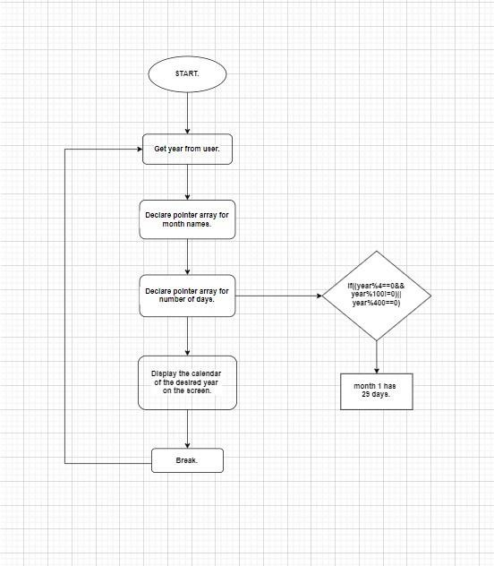

## OUTPUT

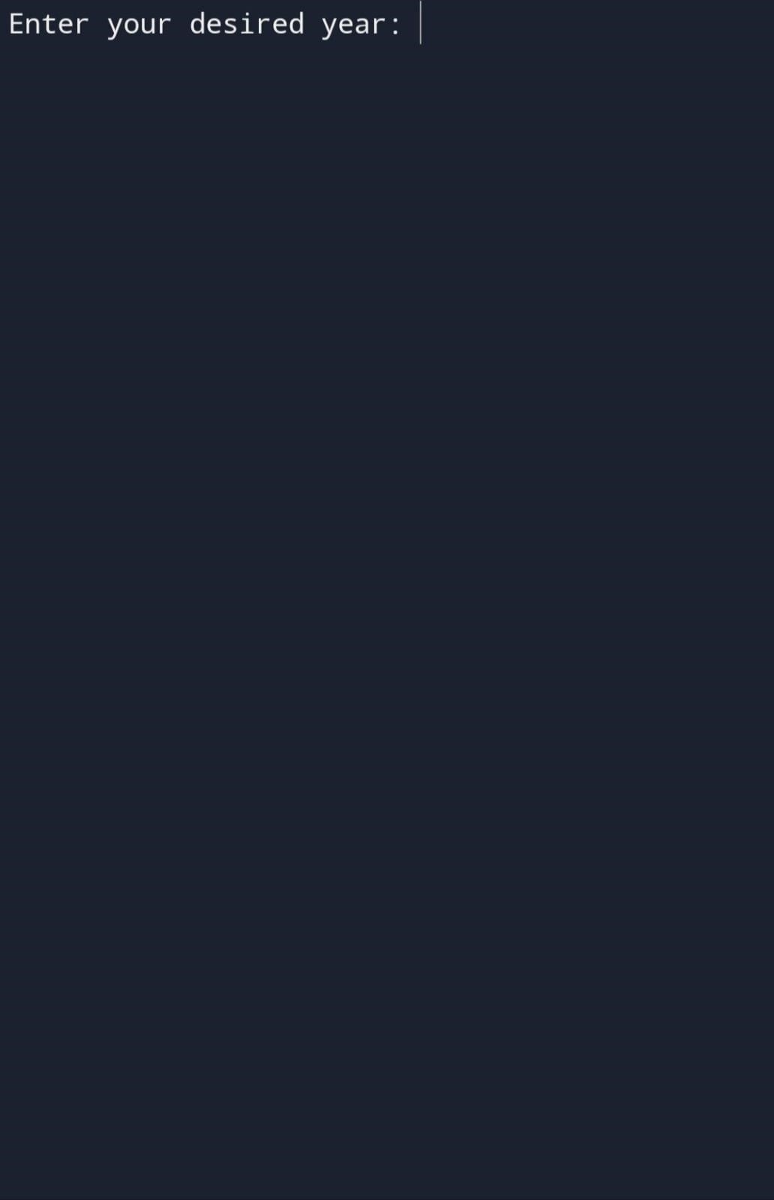

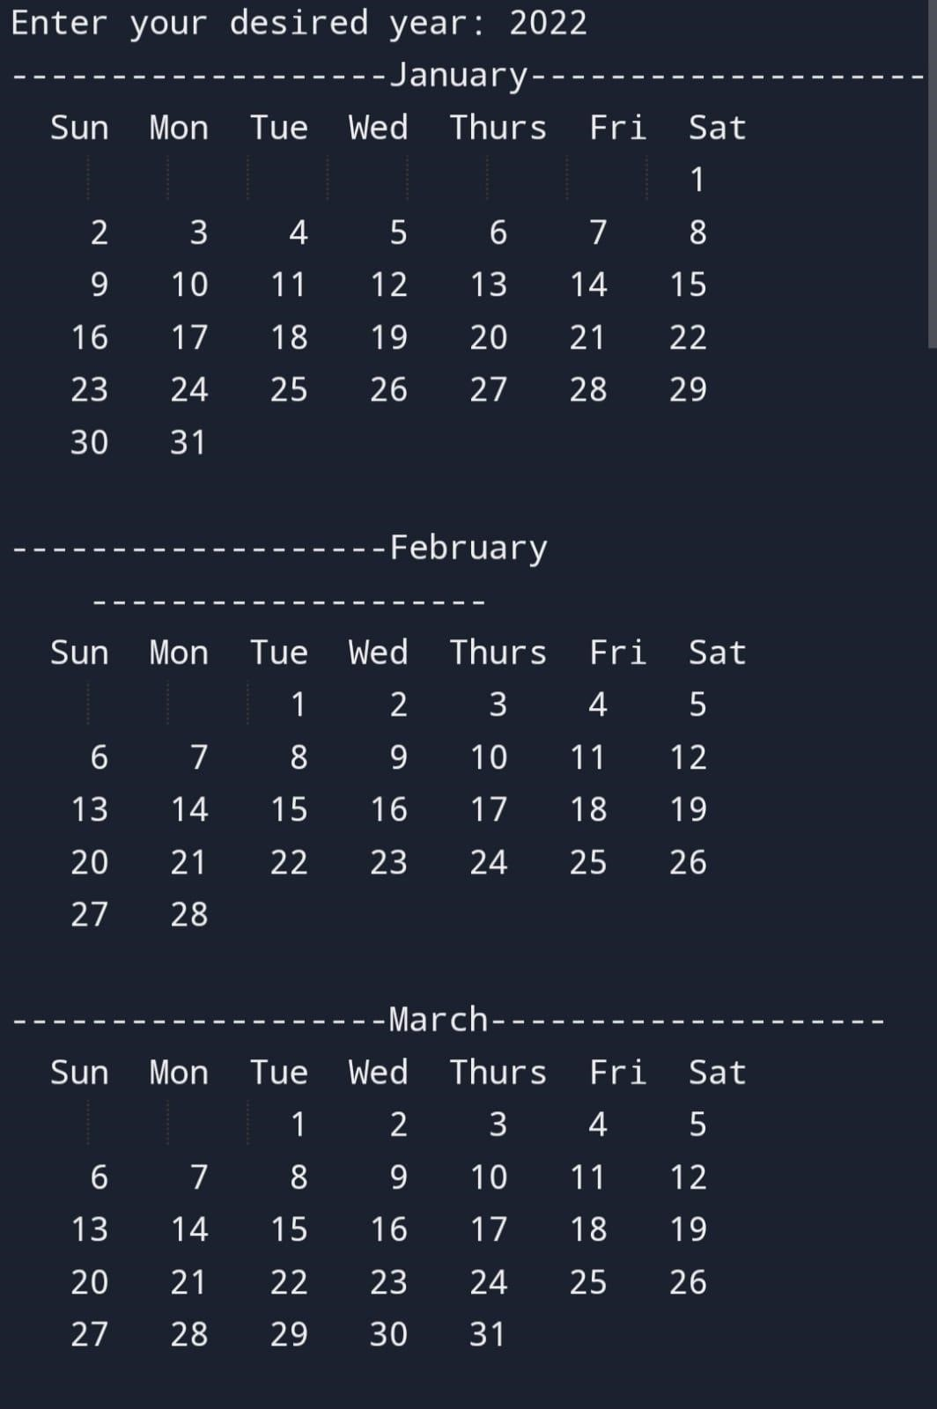

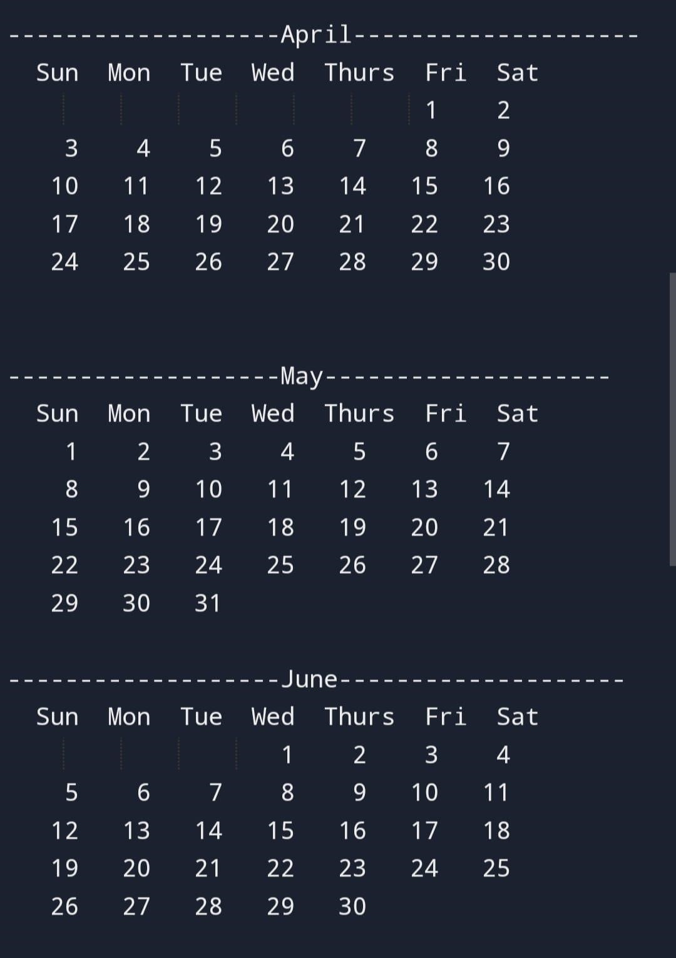

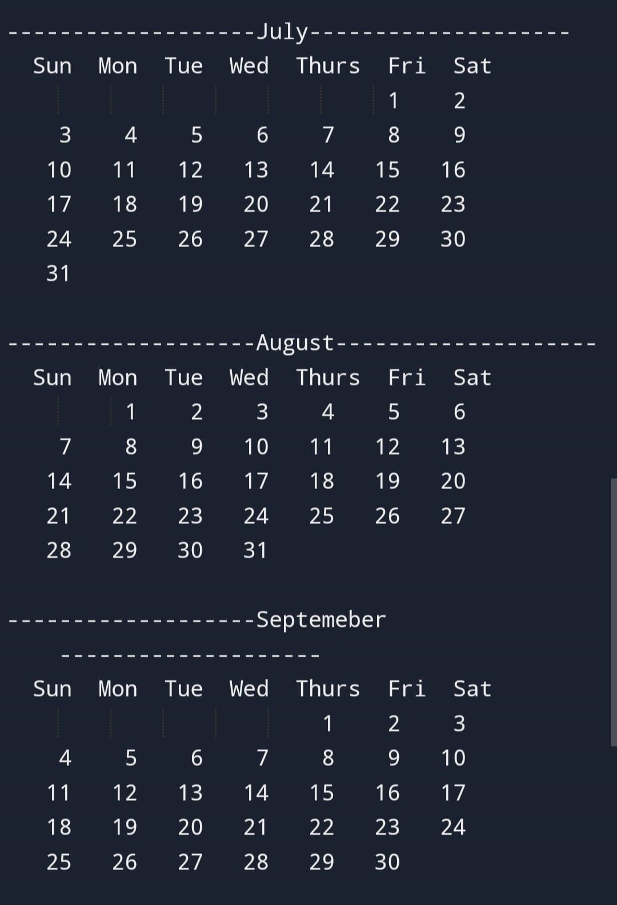

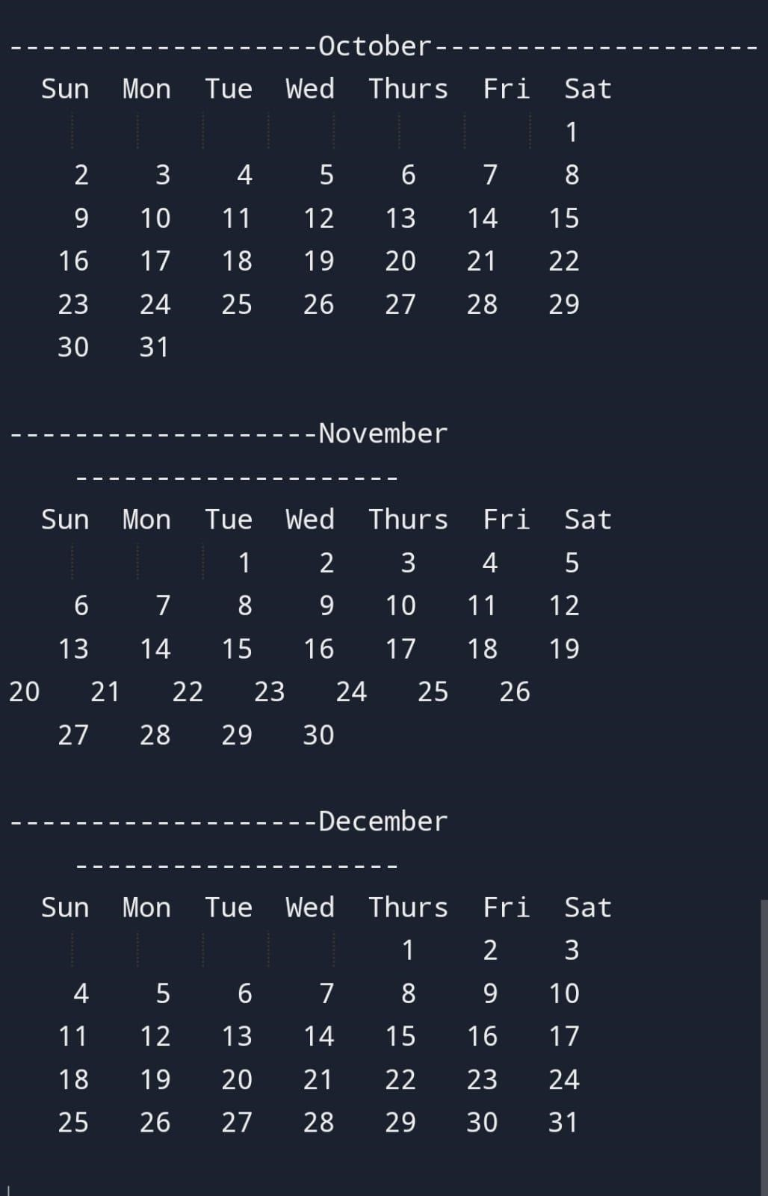

## RESULT

Our project calendar provides an easy access to a formatted calendar of any desired year in a neat and efficient manner.

Our project has succeeded in managing the data and providing the best output.

**CONCLUSION**

C is most useful for embedded systems, or applications that require the ability to be light-weight and have precise control over system resources. C is lacking a lot of the functionality that more contemporary languages feature, but remains a core tool for Unix developers.

The two developers have tried their best to create a simple and optimised program that works as a calendar, with a user-friendly terminal for the executable file of the source code.